# FLOW ELECTROLYSIS CELLS FOR THE SYNTHETIC

*ORGANIC CHEMISTRY LABORATORY*

ABSTRACT: We know how scientist use electricity to make new products and materials by an amazing concept *“ELECTROLYSIS”. It has a wide range of application in our daily life. But due to its limited scalability, it is not suitable*  *for all industrial process. This is where “FLOW* *ELECTROLYSIS”* *comes in, it’s a technique that offers sustainable and efficient way to do electrolysis. It led to high conversion of reactant to* *product by single passage of reactant solution through the cell,* *with reduced energy consumption and improved product quality. In this paper, we review its advantage and its applications. Ongoing research are also discussed on design and developments on flow cells, SPE Electrolyzers, along with the use of novel electrode and their future trends.*

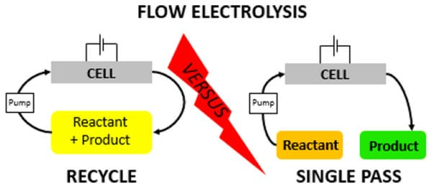

## CONTENTs

1. Introduction

2. General background

2.1. The Principles

2.2. The Rule

2.3. Divided vs undivided

3. Beaker cells and H-cells

4. Parallel Plate cells with flow and solution recycle

5. Pseudo- Parallel plate cells with flow and electrolyte cycle

5.1. SPE Electrolyzers

5.2. Pipe cells

5.3. Bipolar disk Stack cells

6. flow reactors with high conversions in a single pass of reactant solution

6.1. Slowing down the solution flow rate

6.2. Using a three dimensional electrode

6.3. using an extended reactor channel length

7. conclusion and future trends

## 1. INTRODUCTION

In 1800, When scientists first began to explore the relationship between electricity and chemicals reaction, an Italian physicist Alessandro Volta invented the first battery which allowed scientist to generate a study on flow of electric current. Humphry davy used the battery to carry out the first successful electrolysis by isolating Potassium and Sodium from their salts During the 20th century, electrolysis became an essential process for the production of 1 a wide range of metals, such as aluminum, copper, and zinc. It also found applications in the production of chemicals, such as chlorine and hydrogen, and in the refining of petroleum. Many intresting conversions have been reported in books1-4 and reviews5-11 . However, organic electro-synthesis carried out in laboratories , often shows very slow rate conversion (for example, reaction takes many hours for completion in beaker cells).It has many drawbacks including high energy consumption, electrode degradation, electrolyte instability, mass transport limitations, and safety concerns. High energy consumption can result in high operating costs, which can make electrolysis less competitive compared to other chemical synthesis or production methods. Additionally italso contribute to greenhouse gas emission if electricity is generated from fossil

fuel. Electrode degradation and electrolyte instability can limit the reproducibility and

scalability of experiments. These factors should be carefully considered when using

electrolysis as a research tool, and alternative methods may be preferred in some cases.

The introduction of electrolysis into flow synthesis offers a promising alternative to

traditional batch electrolysis and has the potential to improve the sustainability and

efficiency of electrochemical reactions. Flow electrolysis allows for the continuous flow of

reactants through the electrochemical cell, which provides greater control over reaction

conditions and reduces the accumulation of byproducts. This can lead to higher yields by

single passage of reactant solution. The new 4 innovation in electrolysis cell design has

been reviewed recently12-13, especially for synthetic organic laboratory14-16. Recent

interest in micro-flow electrolysis has been reported in the scientific community due to its

potential to overcome some of the limitations of traditional flow electrolysis 17-20.

## 2. GENERAL BACKGROUND

* **The Principle**

The principle of flow electrolysis is based on the fundamental electrochemical principles that govern the behavior of chemical reactions at the electrode-electrolyte interface. In a flow electrolysis system, these principles are applied in a continuous-flow process that allows for more precise control over reaction conditions and product formation. The reactions take place in an electrolytic cell that consists of an anode and a cathode, separated by an ion-permeable membrane. The anode and cathode are typically made of inert materials, such as graphite or platinum, that can withstand the corrosive environment of the electrolytic cell.

When a voltage is applied to the cell, an electrical current flows through the cell, resulting in the oxidation of the reactants at the anode and the reduction of the reactants at the cathode.

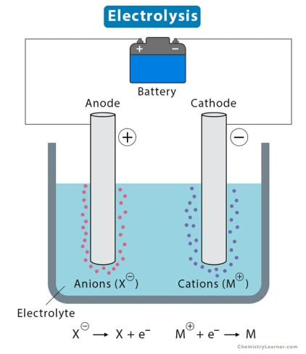

The products of the reaction are formed at the electrode surfaces and can be continuously removed from the cell as they are formed. The flow of reactants and products through the electrolytic cell is controlled by a flow reactor or micro-reactor that is connected to the cell. The flow reactor can be designed to control the flow rate, temperature, and other reaction conditions, allowing for more precise control over the reaction. By controlling the flow of reactants through the cell, the reaction can be optimized to favor the desired product formation and minimize unwanted side reactions. This can lead to higher yields, selectivity, and purity of the final product.

* **The Rule**

The major role of organic electro-synthesis is to convert reactant molecule into reactive

intermediate that then decays to the product. This reaction involve electron transfer,

however if 2e- transferred from reactant (A) to product (P), a oxidative mechanism is

shown below



*Typical electrochemical oxidation mechanism*

1. During electrolysis , 1 the amount of charge Q passed through the cell is calculated by,

$$Q=mnF$$

Where m is number of moles of reactant, n is number of electron taking part in the reaction, F is Faraday constant.

2. when fractional current efficiency is 1.0, the reaction is mass transfer controlled, then the

cell current is calculated by,

$$I=nFAKc$$

Where A is area of electrode, c is concentration of reactant.

3. For mass transfer controlled reaction,

$$X=1-exp\frac{-kAT}{V}$$

Where X is fractional conversion of reactant as a function of time t, V is volume of reactant.

* **Divided and Undivided Cells**

In Divided cells, a separator which made up of porous polymer sheet is placed between two electrodes in order to prevent the formation of unwanted byproducts or interfere with the collection of the desired products .The separator helps to maintain the electrical conductivity of the electrolyte by preventing the movement of ions between the anode and cathode. However there are different types of separators that are used, often show several problem during the process. For example, porous membranes become clogged with reaction products or byproducts over time, which can decrease their efficiency, diaphragms can degrade over time and may release harmful materials into the electrolyte, ion-exchange membranes can be sensitive to pH and temperature changes, which can decrease their efficiency, liquid junctions is that they can be difficult to control, and they can allow for the mixing of products if not designed properly. So, the question arises , can a separator be avoided? The answer is yes, this is only possible if the two electrode do not interfere with each other21. Undivided cells are a 3 type of electrochemical cell that does not have a physical barrier or separator between the anode and cathode compartments. A ‘’paired electro-syntheses’’ is one approach allowing reactions taking part at cathode is inactive at anode while reactions at anode is inactive at cathode .Another approach is to allow the synthesis of 1 same product at both electrode. The different types of glass cells that are used for electro-synthesis :

(a)undivided beaker cell,

(b) beaker cell with porous pot separator, and

(c) H-cell with porous separator.

